

**VOCABULARY:**

1. A GENE is a “factor” that controls a trait.
2. An ALLELE is a different form of a gene.
3. A HYBRID OR HETEROZYGOUS organism has two different alleles for a trait.
4. A DOMINANT allele is one whose trait always shows up in the organism; “stronger”
5. A RECESSIVE allele is one that is hidden or masked; “weaker”
6. GENETICS is the study of heredity.
7. HEREDITY is the passing of genetic traits from parent to offspring.
8. A chart that describes all the ways alleles can combine in a genetic cross is called a(n) PUNNETT SQUARE.
9. An organism’s PHENOTYPE refers to its **physical appearance** or visible traits.
10. An organism’s GENOTYPE refers to its **genetic make-up** or the alleles it has.
11. What is an organism called for having two identical alleles for a trait? HOMOZYGOUS (hh OR HH)
12. What is an organism called for having two different alleles for a trait? HETEROZYGOUS (Hh)

**PUNNETT SQUARE PRACTICE:**

**Use with #13-14: Let’s say that in cats, the gene for the length of the tail has two alleles. The dominant allele (T) codes for long tails and the recessive allele (t) codes for short tails.**

1. What is the probability of producing offspring that have short tails from a cross of two long tailed cats, one that is ***homozygous dominant*** (TT) and one that is ***heterozygous*** (Tt)? Show your work on the Punnett square.

|  |  |  |
| --- | --- | --- |
|  | T | T |
| T | TT | TT |
| t | Tt | Tt |

100% LONG TAILS

0% SHORT TAILS

1. If one parent cat is ***heterozygous long-tailed*** (Tt) and the other is ***short tailed*** (tt), what is the probability that the offspring will have short tails?

|  |  |  |
| --- | --- | --- |
|  | T | t |
| t | Tt | tt |
| t | Tt | tt |

50% LONG TAILS

50% SHORT TAILS

1. In unicorns, two horns (H) is dominant and one horn (h) is recessive. Complete the Punnett square to show the cross of ***two hybrid*** (Hh) unicorns. Summarize the genotypes and phenotypes of the possible offspring.

POSSIBLE GENOTYPES: HH, Hh, AND hh

POSSIBLE PHENOTYPES: TWO HORNS AND ONE HORN

|  |  |  |
| --- | --- | --- |
|  | H | h |
| H | HH | Hh |
| h | Hh | hh |

SUMMARY: Based on the information from the Punnett Square we can predict that 75% of the offspring would have two horns because they all have a dominant allele. We can also predict that 25% would have one horn because they have two recessive alleles.

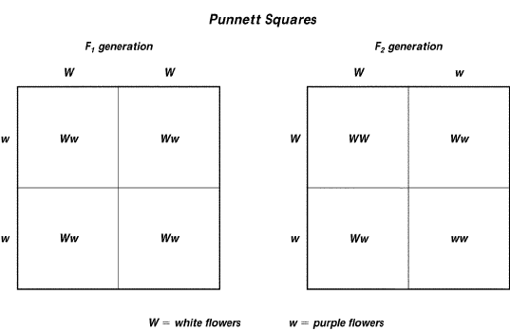**USE THE PUNNETT SQUARE TO THE RIGHT TO ANSWER THE QUESTIONS BELOW.**

1. Which trait—white flowers or purple flowers—is controlled by a dominant allele? WHITE
2. In which generation (F1 or F2) are the parents hybrids?

F2

1. In the F1 generation, what is the genotype of the offspring?

HETEROZYGOUS (hybrid) Ww

1. In the F2 generation, what percent of the offspring have purple flowers? 25%

**COMPLETE THE FOLLOWING CHART:**



Yellow flowers (Y) are dominant to white flowers (y). What are the genotypes and phenotypes for the following?

|  |  |  |
| --- | --- | --- |
|  | Genotype | Phenotype |
| Homozygous dominant | YY | YELLOW |
| Homozygous recessive | Yy | YELLOW |
| Heterozygous | Yy | WHITE |

1. Single-celled organisms can reproduce and create cells exactly like themselves without combining genes from two different parent cells. When they do this, what type of reproduction do they use and why?

Asexual reproduction is the type of reproduction that only needs one parent cell.

1. A farmer combines the best traits from a horse with the best traits from a donkey so that the offspring will have the best traits for farming. He creates a hybrid known as a mule. This is an example of ….

Selective breeding is where the best traits are utilized to breed new offspring.

1. Which is the best assumption the scientists can make, based on the information provided in the passage below? *Suppose some scientists traveling on the ocean came upon a small island that had not been explored before. They discovered a new kind of animal with colored fur. Since the island was isolated, they could count all of these animals. They discovered that there were exactly 100 of the colored animals and that 25 animals had green fur, while the remaining 75 had blue fur.*

The assumption could be made that Blue fur was a more dominant gene than the Green fur because the greater percentage of animals had that fur. Since the dominant gene covers the recessive gene it is assumed there would be a higher percentage of the dominant gene.

1. What are the differences in organisms that reproduce sexually vs. asexually?

Asexual organisms are only one parent. The offspring is identical to the parent. Asexual organisms reproduce faster than sexual reproduction. Sexual reproduction is two parents and the offspring is a mixture of both parents.