

**VOCABULARY:**

1. A _____________________________is a “factor” that controls a trait.
2. An______________________________is a different form of a gene.
3. A ____________________________organism has two different alleles for a trait.
4. A__________________________allele is one whose trait always shows up in the organism; “stronger”
5. A ___________________________allele is one that is hidden or masked; “weaker”
6. _____________________________is the study of heredity.
7. _______________________________is the passing of genetic traits from parent to offspring.
8. A chart that describes all the ways alleles can combine in a genetic cross is called a(n) __________________________________.
9. An organism’s ______________________________refers to its **physical appearance** or visible traits.
10. An organism’s ______________________________refers to its **genetic make-up** or the alleles it has.
11. What is an organism called for having two identical alleles for a trait? __________________________
12. What is an organism called for having two different alleles for a trait?__________________________

**PUNNETT SQUARE PRACTICE:**







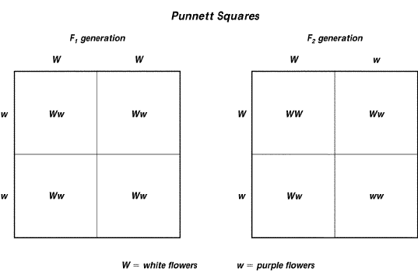

**USE THE PUNNETT SQUARE TO THE RIGHT TO ANSWER THE QUESTIONS BELOW.**

1. Which trait—white flowers or purple flowers—is controlled by a dominant allele?
2. In which generation (F1 or F2) are the parents hybrids?
3. In the F1 generation, what is the genotype of the offspring?
4. In the F2 generation, what percent of the offspring have purple flowers?

**COMPLETE THE FOLLOWING CHART:**

Yellow flowers (Y) are dominant to white flowers (y). What are the genotypes and phenotypes for the following?

|  |  |  |
| --- | --- | --- |
|  | Genotype | Phenotype |
| Homozygous dominant |  |  |
| Homozygous recessive |  |  |
| Heterozygous |  |  |

2. Single-celled organisms can reproduce and create cells exactly like themselves without combining genes from two different parent cells. When they do this, what type of reproduction do they use and why?
3. A farmer combines the best traits from a horse with the best traits from a donkey so that the offspring will have the best traits for farming. He creates a hybrid known as a mule. This is an example of ….
4. Which is the best assumption the scientists can make, based on the information provided in the passage below? *Suppose some scientists traveling on the ocean came upon a small island that had not been explored before. They discovered a new kind of animal with colored fur. Since the island was isolated, they could count all of these animals. They discovered that there were exactly 100 of the colored animals and that 25 animals had green fur, while the remaining 75 had blue fur.*
5. What are the differences in organisms that reproduce sexually vs. asexually?